Community Property State Filing

https://www.irs.gov/pub/irs-pdf/p555.pdf

https://www.taxact.com/support/1662/2021/community-property-states-federal-allocation-record-married-filing-separate

IRS Publication 555 Community Property addresses income and deduction reporting for individuals and their spouse/partner living in a community property state. It outlines when an individual filing separately from their spouse/partner must report half of their combined community income and deductions in addition to their separate income and deductions.
Community Property states include Arizona, California, Idaho, Louisiana, Nevada, New Mexico, Texas, Washington, and Wisconsin. For individuals considered married for federal tax purposes, the spouses must each follow these instructions if they live in any of the community property states listed.
Individuals considered Registered Domestic Partners (RDPs) must follow these instructions if they live in Nevada, Washington, or California.

UltraTax ’21 Process

Fill out the UltraTax return as if the individuals were Married Filing Joint. Include W2s and all deductions/credits for both individuals.

If filing Single / Head of Household ONLY, within the US – General drawer select tab “ComPSt” and place a tickmark on the “Domestic partner return in CA, NV, WA.”

Once all data is entered as MFJ, go to utilities and select filing status optimization.
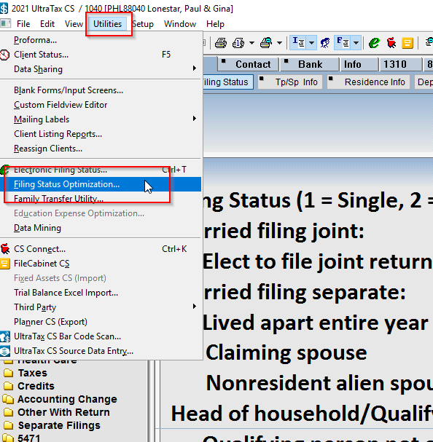\

Choose the Community Prop / Filing Status / Other tab at the top. Select the top tickmark stating to split income according to Community Property rules.

Tick the “Save clients upon exit” tickmark.

